The basic job of computers is the processing of information.



For this reason computers can be defined as devices which accept information in the form of instructions

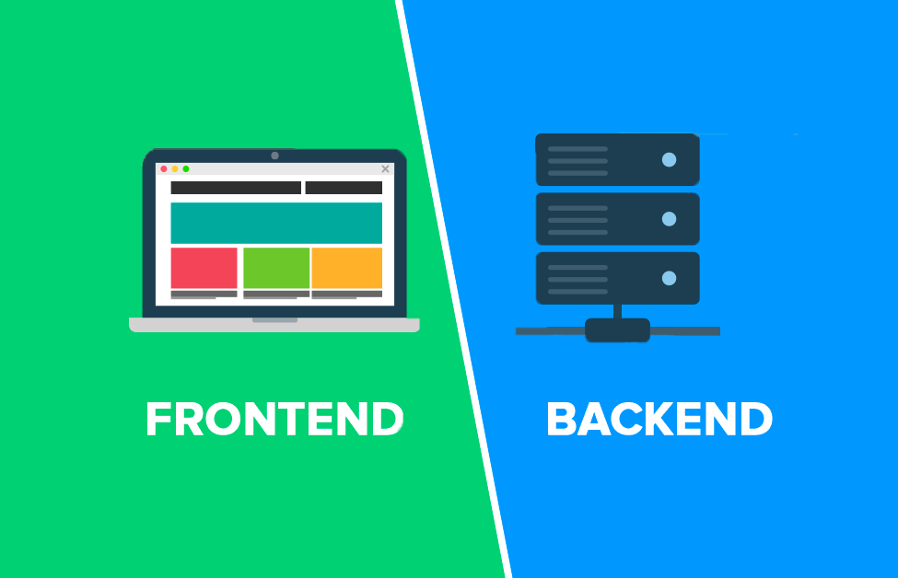

called a program



and characters called data.

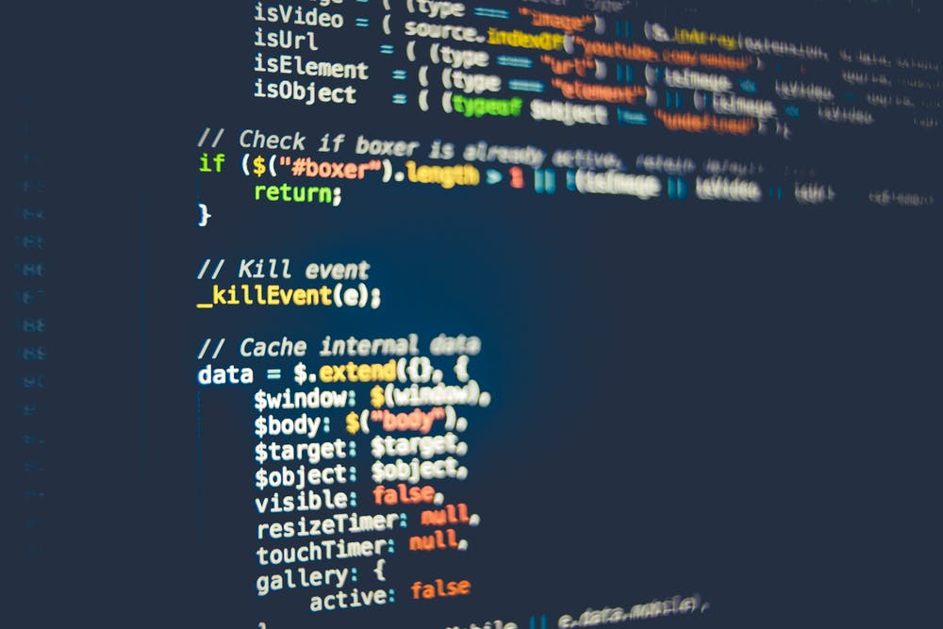

Computers then perform mathematical and/or logical operations using this information, and supply the results of these operations

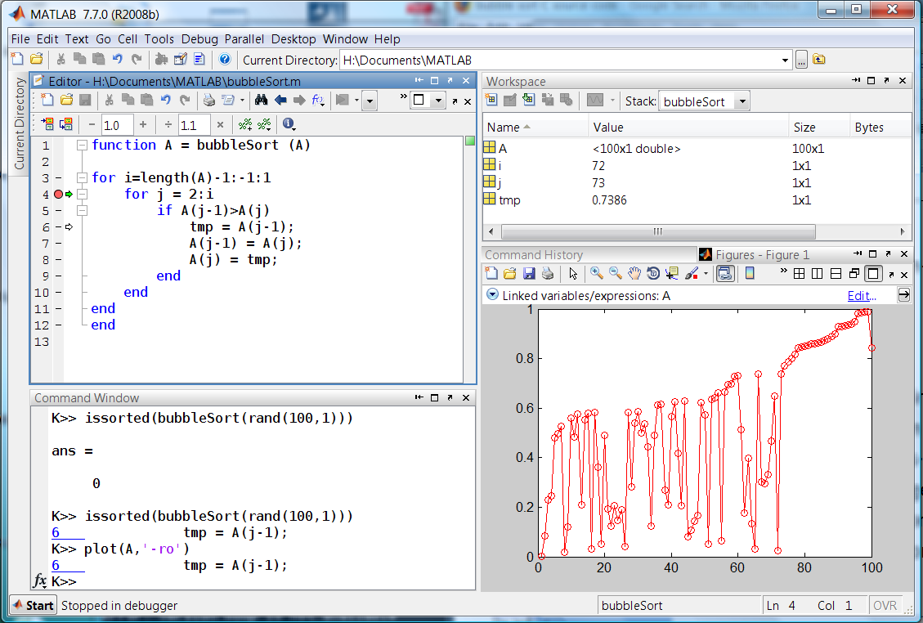

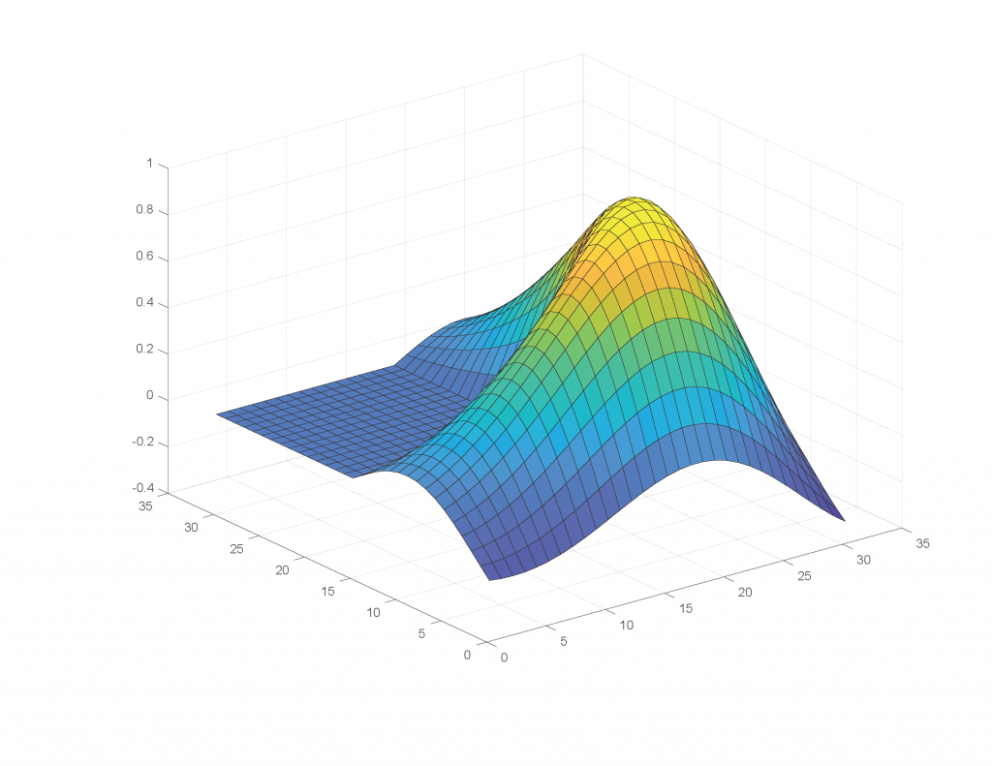

The program, or part of it, which tells the computers what to do and the data, which provide the information

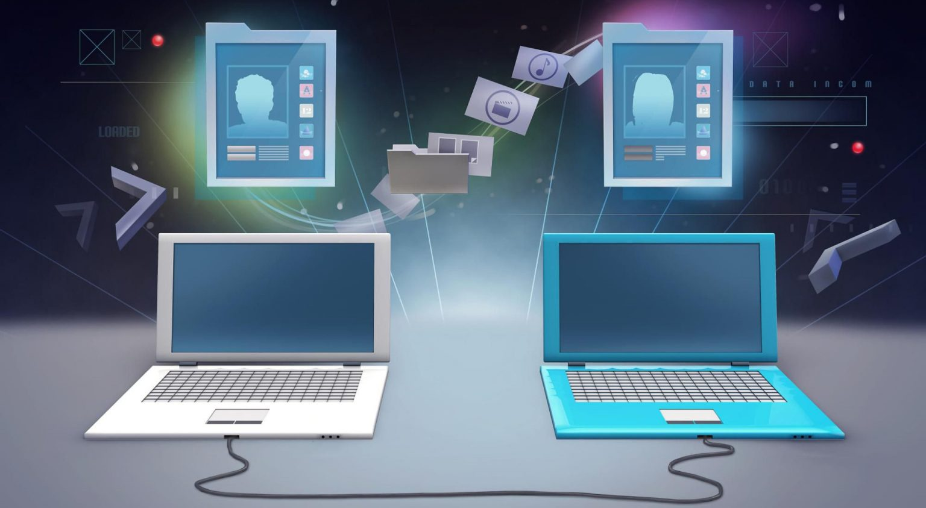

needed to solve the problem, are kept inside that part of the computer called memory.

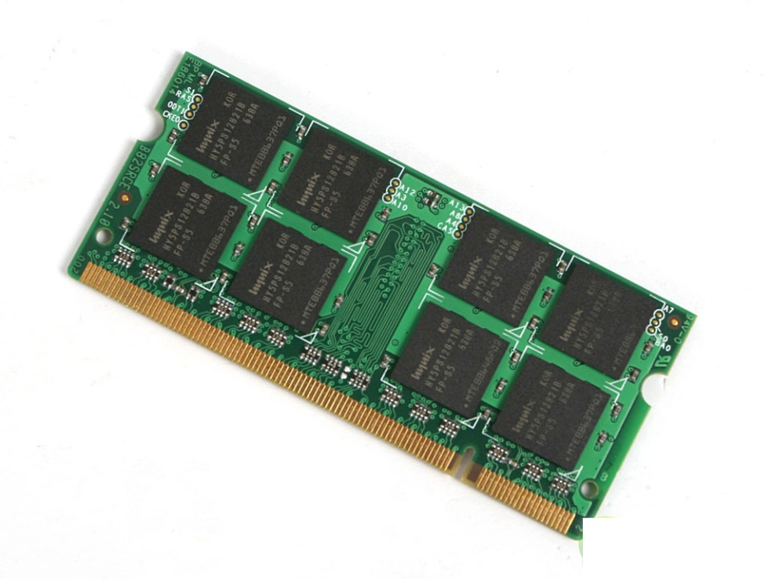

The computer is capable of storing and manipulating numbers, letters, and characters.



A computer has three main parts: the keyboard, the computer unit and the monitor.

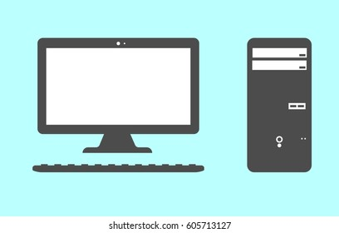

The main method of inputting information is by using terminals, diskettes, disks and magnetic tape.

The computer's input device reads the information into the computer's memory

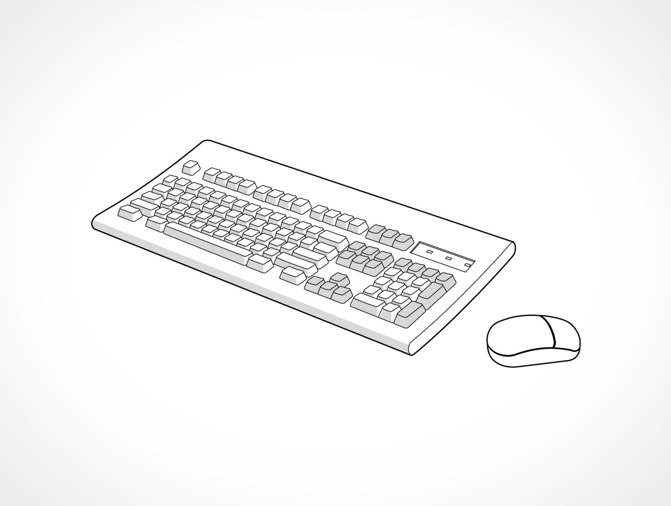

For outputting information a printer which prints the information on paper,

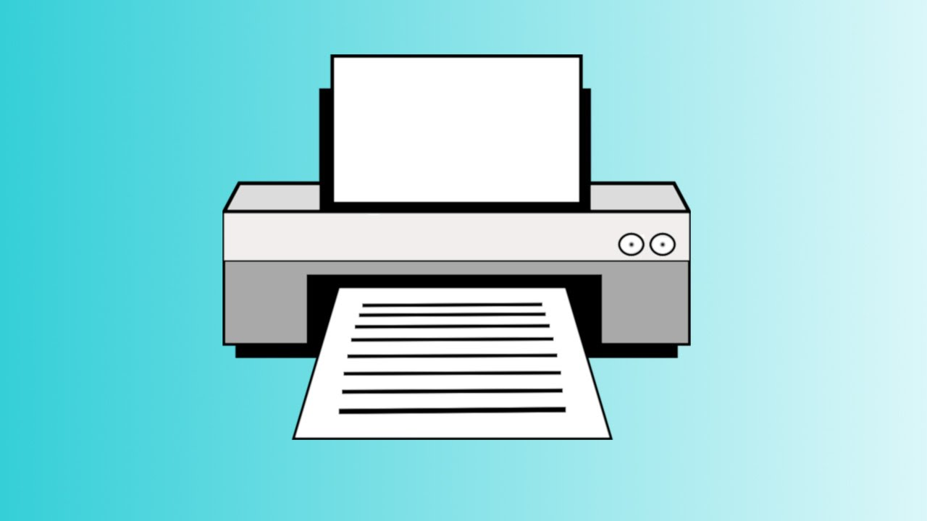

or a display which shows the results on a screen are utilized.



The information is stored on disks, diskettes and magnetic tape as files.

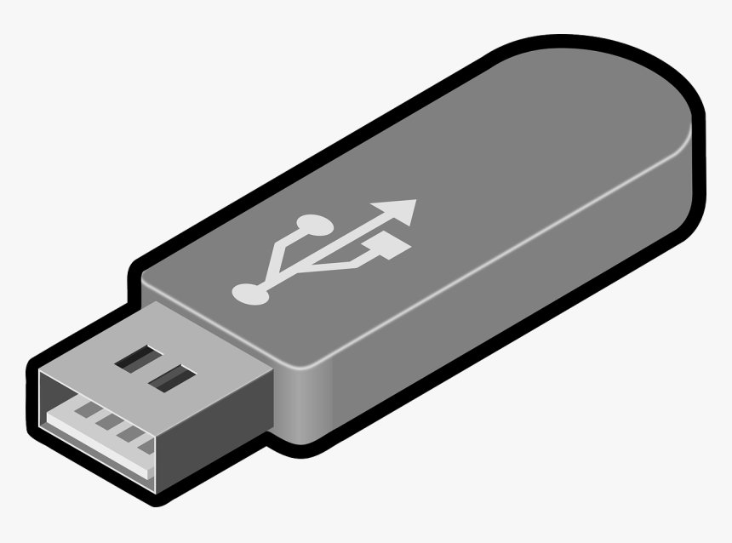

One of the operations with files is to copy them, usually from one disk to another or from one directory to another.

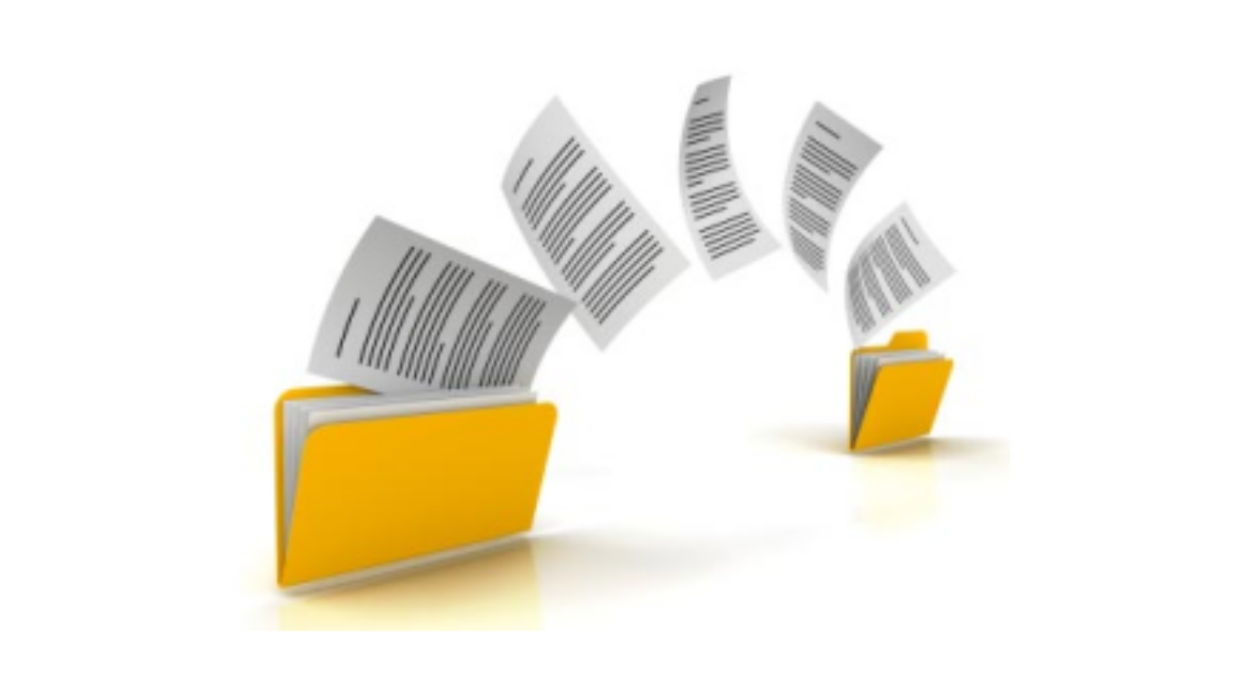

The Copy command is essential to your operating system.

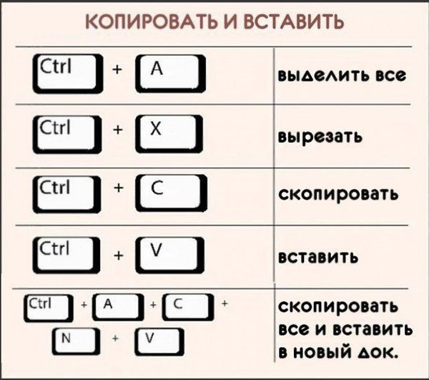

The Copy command creates an identical file but does not alter or remove the original.

